Electronic Distance Measurement (EDM)
# Source: AI Source: Provided by: [Data Path: Persons Table -> ID Column: 1, Name_En Column: Motasem Essam] -> From: [ChatGPT] on [7/17/2026]
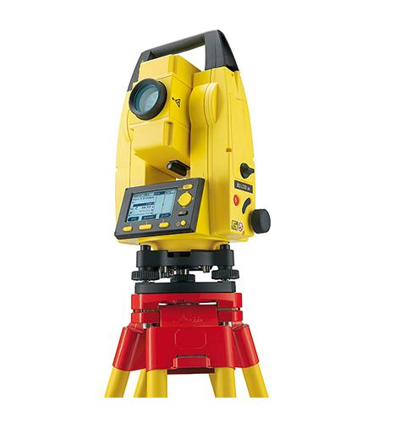
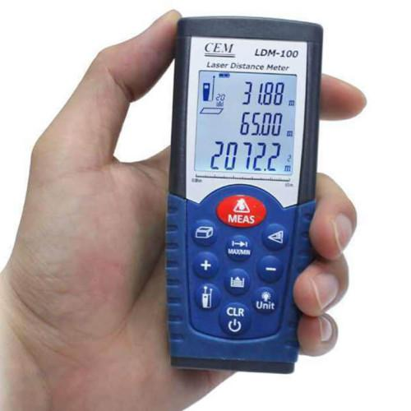
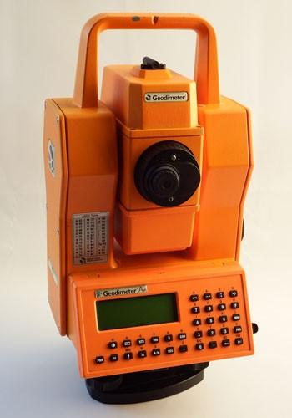
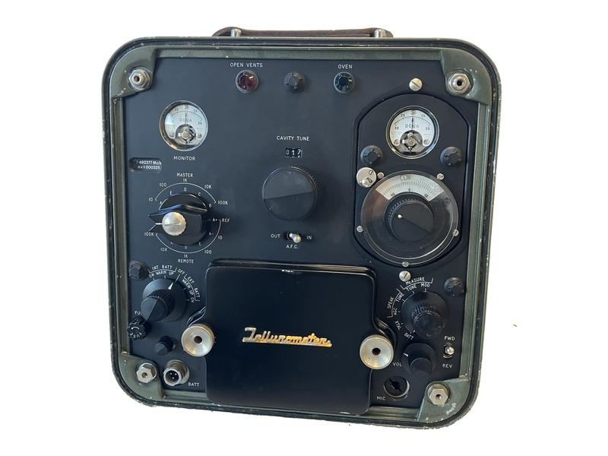
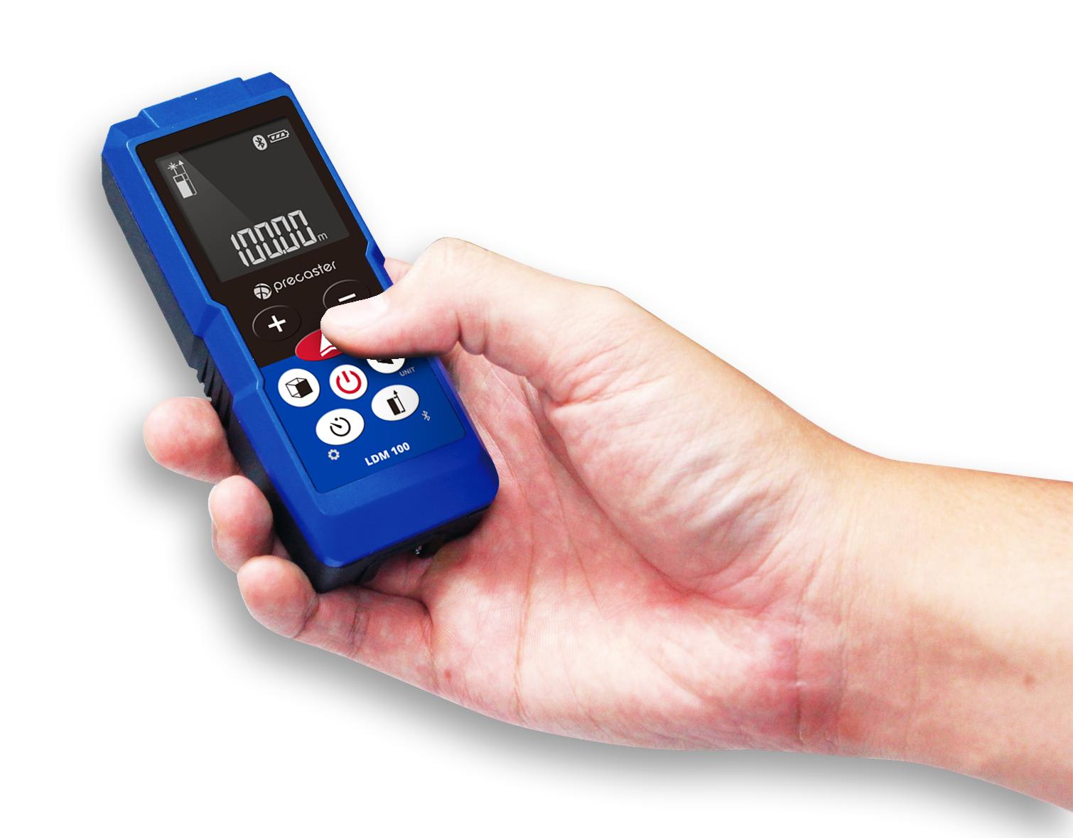
Note: Although an Electronic Distance Measurement (EDM) instrument is primarily used to measure distance, it is commonly grouped with surveying angle instruments because it is frequently integrated with theodolites and total stations for measuring both angles and distances in surveying.

Definition
# Source: AI Source: Provided by: [Data Path: Persons Table -> ID Column: 1, Name_En Column: Motasem Essam] -> From: [ChatGPT] on [7/17/2026]
An Electronic Distance Measurement (EDM) instrument is an electronic surveying device that measures the distance between two points by transmitting electromagnetic waves (laser, infrared, visible light, or microwave) and calculating the travel time or phase difference of the returned signal.

Purpose
# Source: AI Source: Provided by: [Data Path: Persons Table -> ID Column: 1, Name_En Column: Motasem Essam] -> From: [ChatGPT] on [7/17/2026]
An EDM is used to:
- Measure horizontal distance.
- Measure slope distance.
- Support land surveying.
- Assist construction layout.
- Measure long distances accurately.
- Support mapping and geodesy.
- Work with total stations for coordinate measurement.

Principle of Operation
# Source: AI Source: Provided by: [Data Path: Persons Table -> ID Column: 1, Name_En Column: Motasem Essam] -> From: [ChatGPT] on [7/17/2026]
An EDM measures distance by transmitting an electromagnetic signal toward a reflector or target and determining the distance using:
- Travel time of the signal, or
- Phase difference between transmitted and returned waves.

Main Components
# Source: AI Source: Provided by: [Data Path: Persons Table -> ID Column: 1, Name_En Column: Motasem Essam] -> From: [ChatGPT] on [7/17/2026]
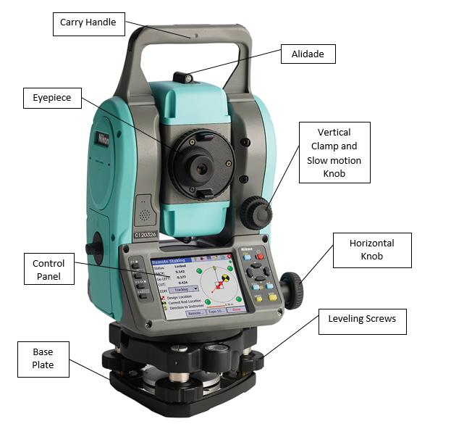
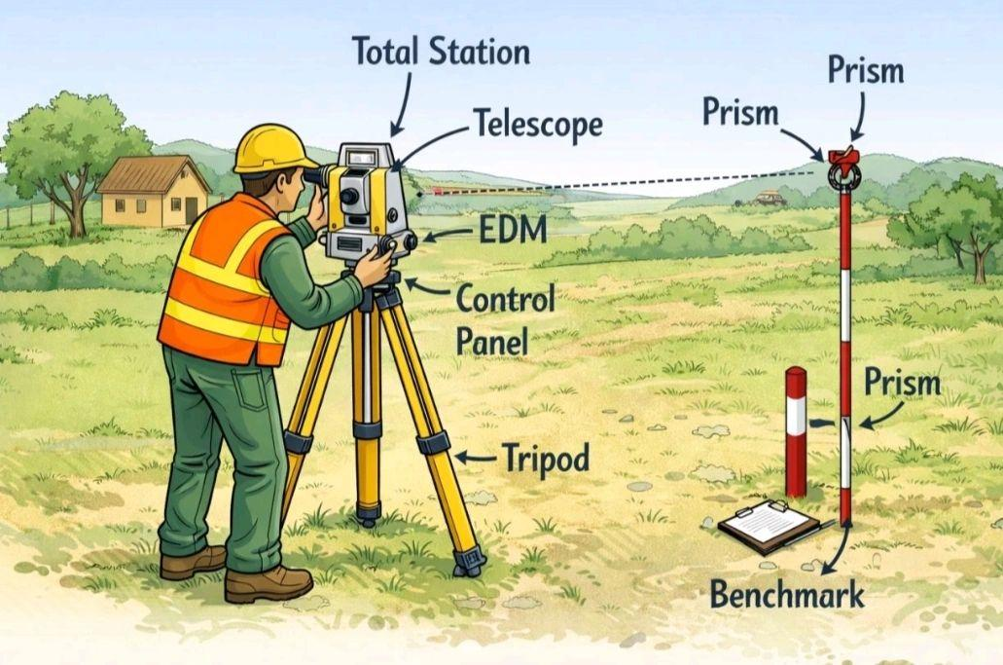
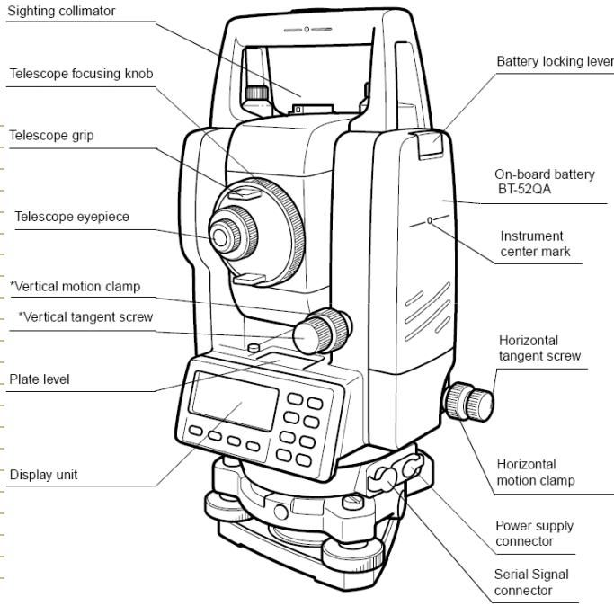
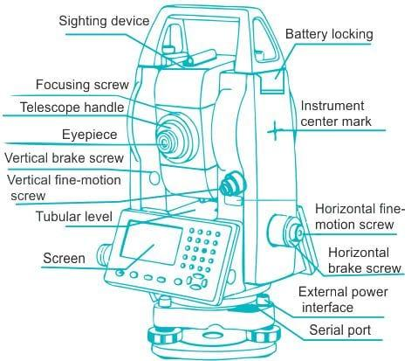
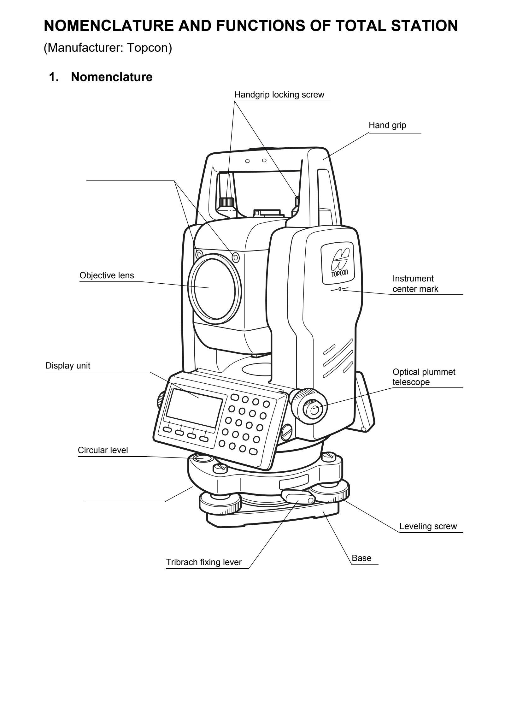
A typical EDM consists of:
- Signal transmitter
- Receiver
- Optical telescope (survey models)
- Display and keypad
- Distance processor
- Power supply
- Reflector (prism) or reflectorless laser system

Types of EDM Instruments

1. Infrared EDM
# Source: AI Source: Provided by: [Data Path: Persons Table -> ID Column: 1, Name_En Column: Motasem Essam] -> From: [ChatGPT] on [7/17/2026]
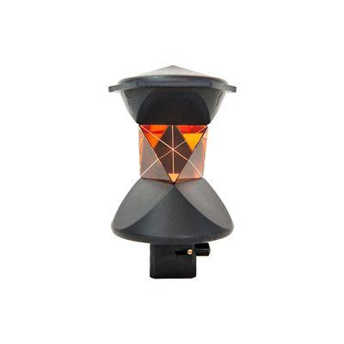
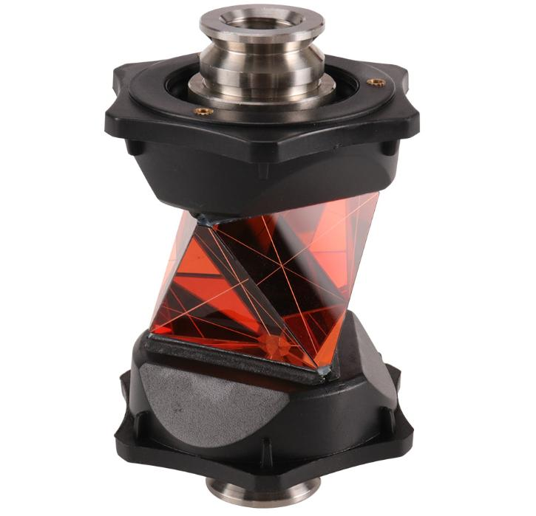
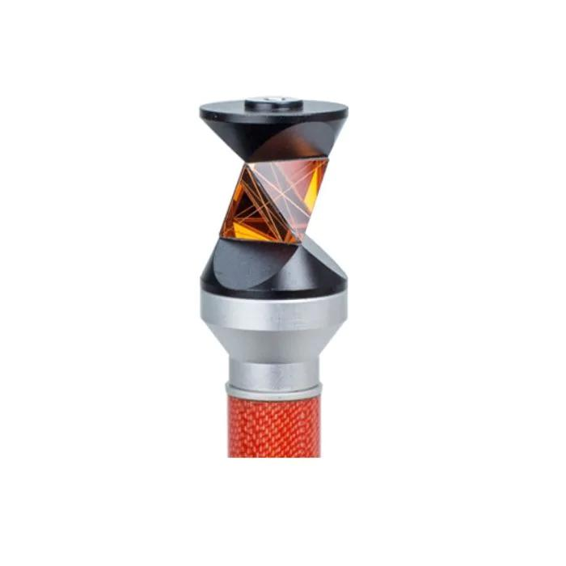
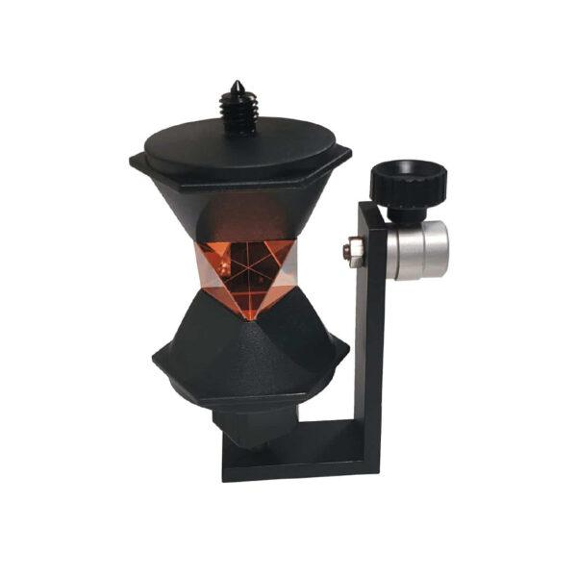
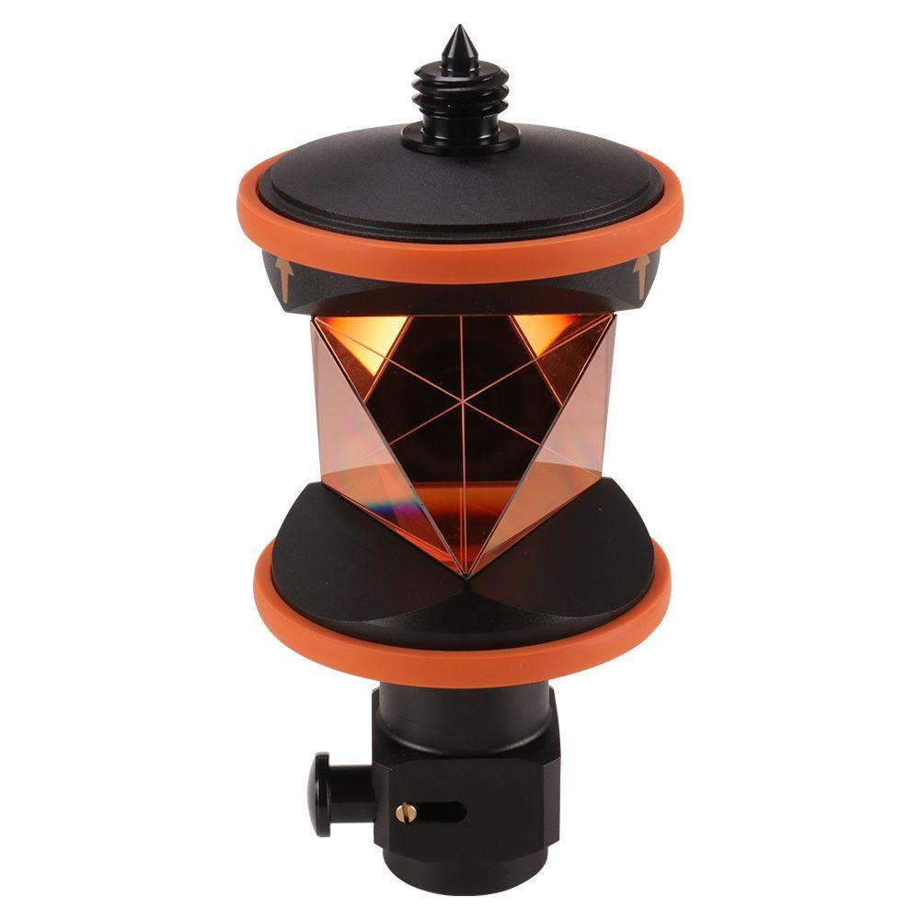
Description
Uses infrared light reflected from a prism to accurately measure distances.
Features
- Requires a reflective prism
- High accuracy
- Long measuring range
Applications
- Land surveying
- Construction
- Civil engineering

2. Laser EDM
# Source: AI Source: Provided by: [Data Path: Persons Table -> ID Column: 1, Name_En Column: Motasem Essam] -> From: [ChatGPT] on [7/17/2026]

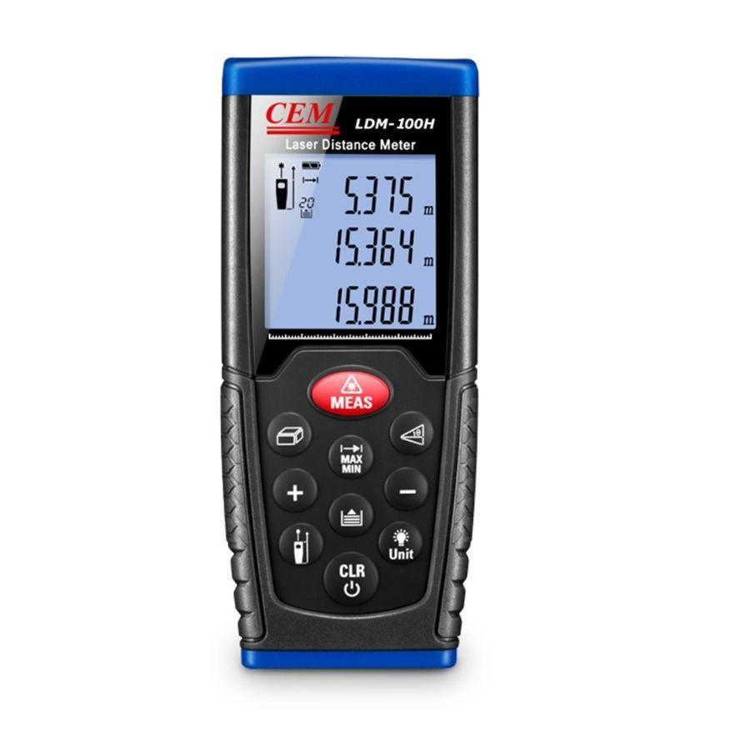
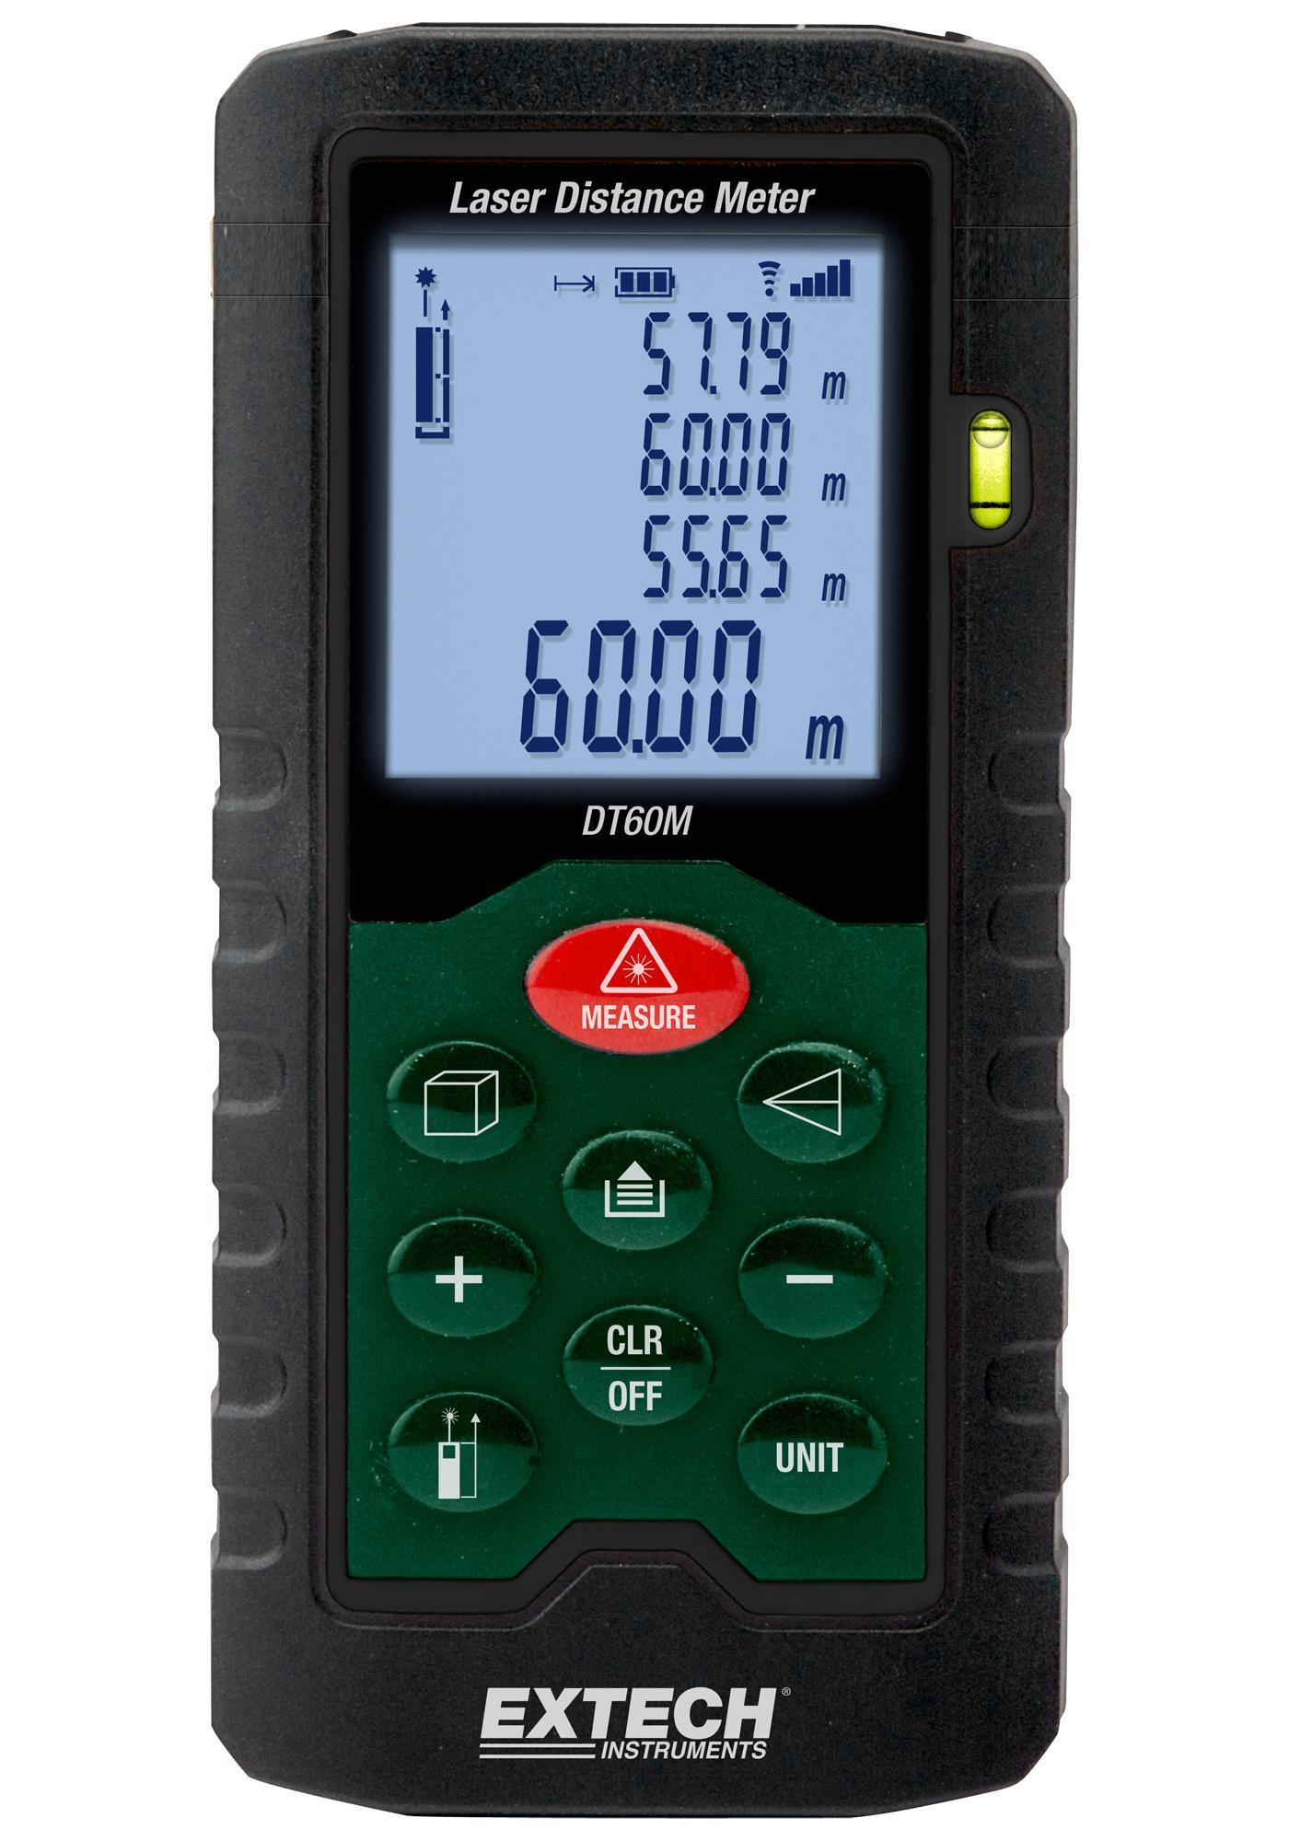
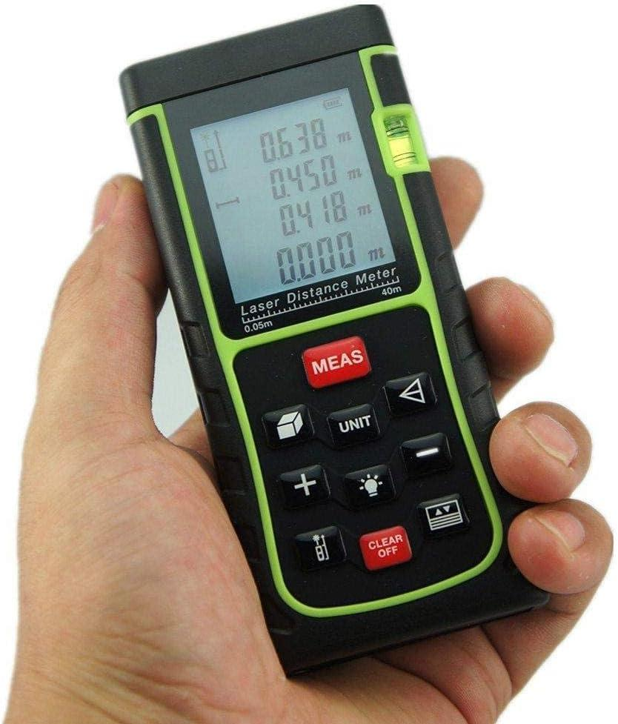
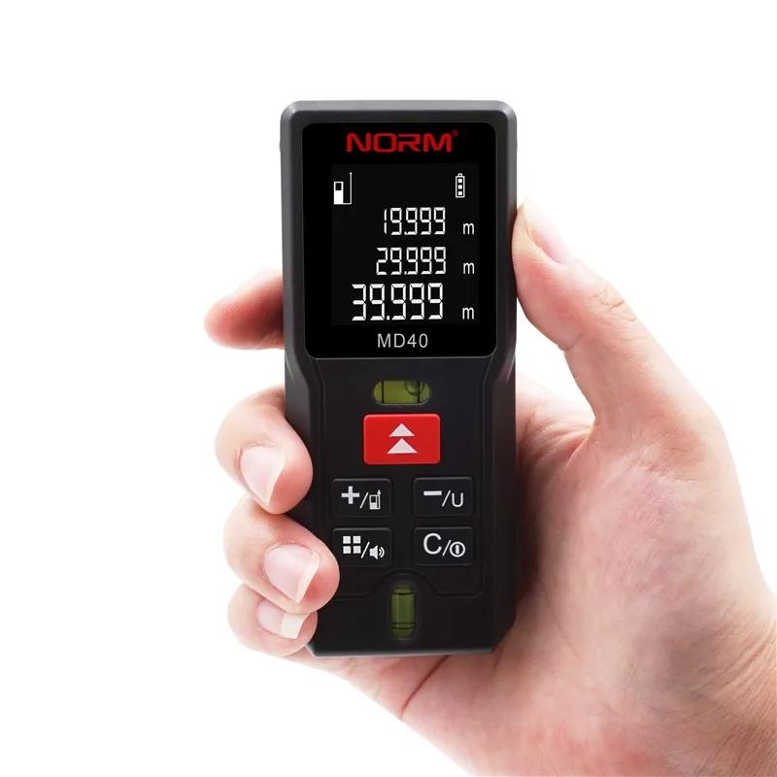
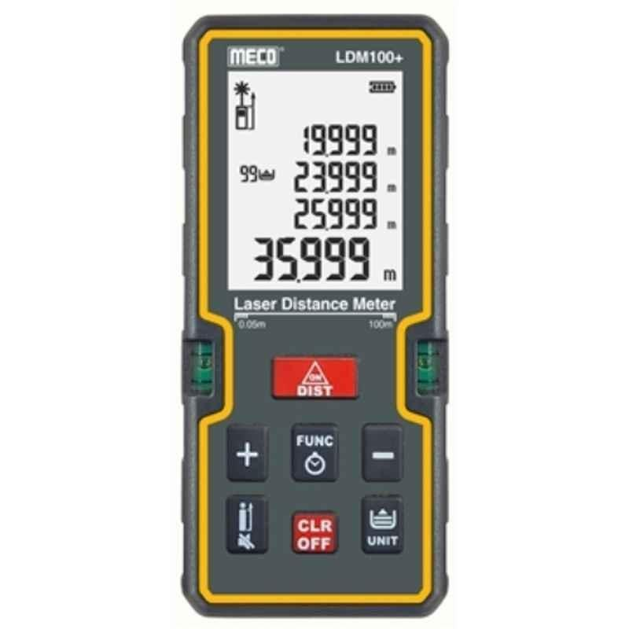
Description
Uses a laser beam to measure distance directly to a target, often without requiring a prism.
Features
- Reflectorless measurement
- Compact and portable
- Fast operation
Applications
- Building construction
- Interior measurements
- Architecture
- Facility management

3. Microwave EDM
# Source: AI Source: Provided by: [Data Path: Persons Table -> ID Column: 1, Name_En Column: Motasem Essam] -> From: [ChatGPT] on [7/17/2026]
Description
Uses microwave signals for measuring very long distances between two stations.
Features
- Extremely long range
- High precision
- Suitable for geodetic surveys
Applications
- National mapping
- Geodesy
- Long-distance surveying

4. Total Station EDM
# Source: AI Source: Provided by: [Data Path: Persons Table -> ID Column: 1, Name_En Column: Motasem Essam] -> From: [ChatGPT] on [7/17/2026]
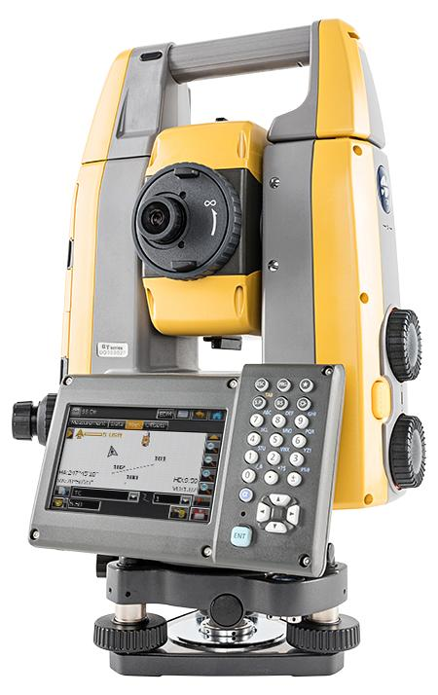
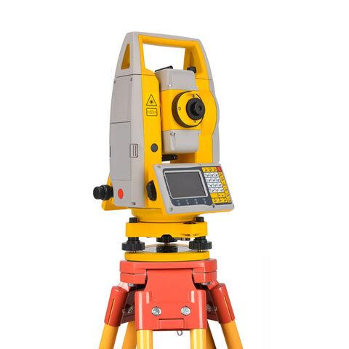
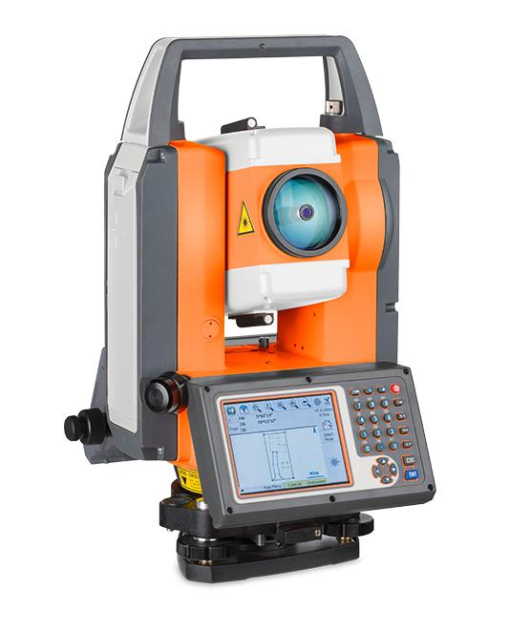
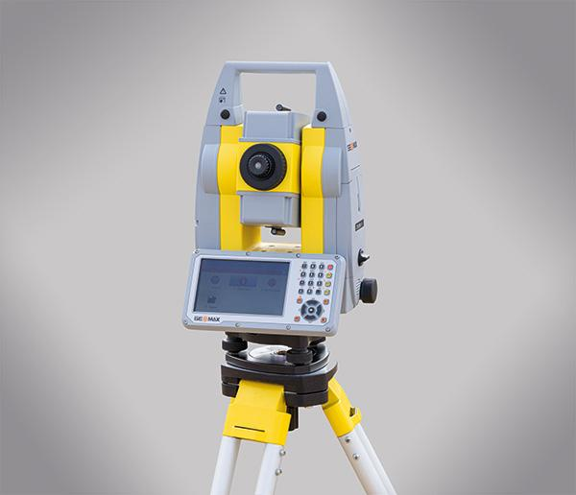
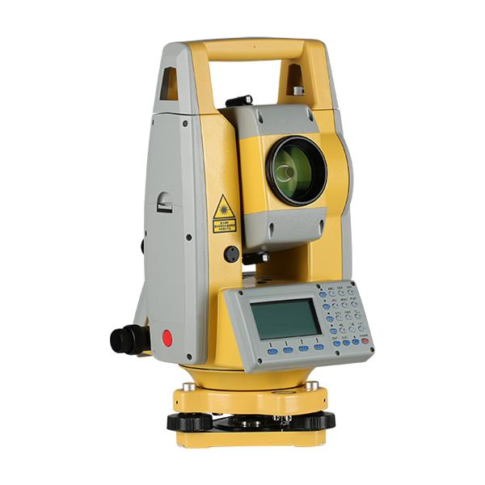
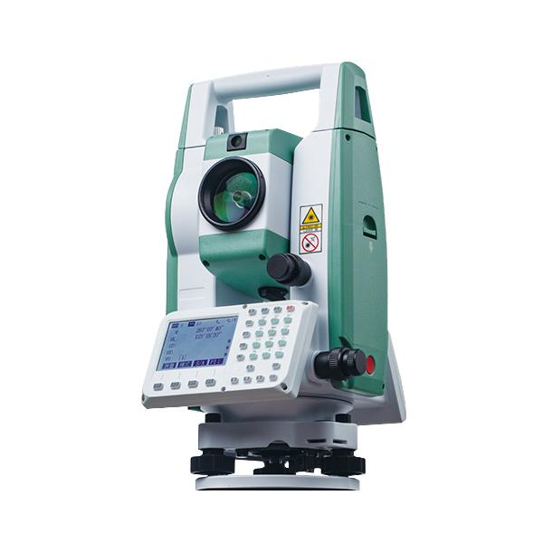
Description
Integrates an Electronic Distance Measurement (EDM) unit with an electronic theodolite, allowing simultaneous measurement of angles and distances.
Features
- Measures angles and distances
- Calculates coordinates automatically
- Stores digital survey data
Applications
- Surveying
- Road construction
- Building layout
- Civil engineering
- Topographic mapping

Measuring Units
# Source: AI Source: Provided by: [Data Path: Persons Table -> ID Column: 1, Name_En Column: Motasem Essam] -> From: [ChatGPT] on [7/17/2026]
EDM instruments commonly measure:
- Millimeter (mm)
- Centimeter (cm)
- Meter (m)
- Kilometer (km)
- Foot (ft)

Measuring Range
# Source: AI Source: Provided by: [Data Path: Persons Table -> ID Column: 1, Name_En Column: Motasem Essam] -> From: [ChatGPT] on [7/17/2026]
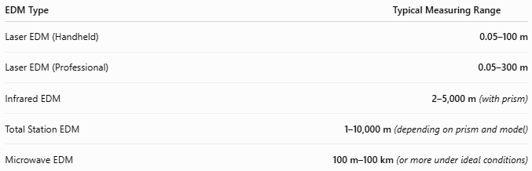
EDM Type | Typical Measuring Range
Laser EDM (Handheld) | 0.05–100 m
Laser EDM (Professional) | 0.05–300 m
Infrared EDM | 2–5,000 m (with prism)
Total Station EDM | 1–10,000 m (depending on prism and model)
Microwave EDM | 100 m–100 km (or more under ideal conditions)

Resolution
# Source: AI Source: Provided by: [Data Path: Persons Table -> ID Column: 1, Name_En Column: Motasem Essam] -> From: [ChatGPT] on [7/17/2026]
Resolution is the smallest distance increment that can be displayed.
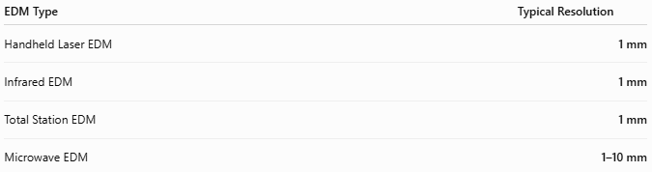
EDM Type | Typical Resolution
Handheld Laser EDM | 1 mm
Infrared EDM | 1 mm
Total Station EDM | 1 mm
Microwave EDM | 1–10 mm

Accuracy
# Source: AI Source: Provided by: [Data Path: Persons Table -> ID Column: 1, Name_En Column: Motasem Essam] -> From: [ChatGPT] on [7/17/2026]
Accuracy indicates how closely the measured distance matches the true distance.
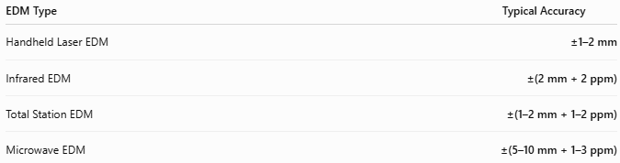
EDM Type | Typical Accuracy
Handheld Laser EDM | ±1–2 mm
Infrared EDM | ±(2 mm + 2 ppm)
Total Station EDM | ±(1–2 mm + 1–2 ppm)
Microwave EDM | ±(5–10 mm + 1–3 ppm)
Notes
- ppm (parts per million) represents an additional error proportional to the measured distance.
Example: ±(2 mm + 2 ppm) means:
  - At 1,000 m, the total error is approximately ±4 mm.
- Laser EDMs are ideal for short- and medium-range measurements.
- Infrared EDMs generally require a reflective prism for maximum range.
- Microwave EDMs are designed for extremely long-distance geodetic surveys.
- Atmospheric conditions (temperature, pressure, humidity, dust, rain, and heat shimmer) can affect measurement accuracy, especially over long distances.

How to Use an EDM
# Source: AI Source: Provided by: [Data Path: Persons Table -> ID Column: 1, Name_En Column: Motasem Essam] -> From: [ChatGPT] on [7/17/2026]
- Set up the instrument on a stable tripod.
- Level the instrument.
- Aim at the prism or target.
- Select the measurement mode.
- Start the measurement.
- Read the displayed distance.

Example
# Source: AI Source: Provided by: [Data Path: Persons Table -> ID Column: 1, Name_En Column: Motasem Essam] -> From: [ChatGPT] on [7/17/2026]
Displayed reading:
245.683 m
Measured distance:
245.683 meters

Applications
# Source: AI Source: Provided by: [Data Path: Persons Table -> ID Column: 1, Name_En Column: Motasem Essam] -> From: [ChatGPT] on [7/17/2026]
EDMs are used in:
- Land surveying
- Civil engineering
- Construction
- Mining
- Geodesy
- Road construction
- Tunnel surveying
- Utility mapping
- Architecture

Advantages
# Source: AI Source: Provided by: [Data Path: Persons Table -> ID Column: 1, Name_En Column: Motasem Essam] -> From: [ChatGPT] on [7/17/2026]
An EDM:
- Provides very high accuracy.
- Measures long distances rapidly.
- Reduces manual measurement errors.
- Stores measurement data digitally.
- Integrates easily with total stations and GPS systems.

Limitations
# Source: AI Source: Provided by: [Data Path: Persons Table -> ID Column: 1, Name_En Column: Motasem Essam] -> From: [ChatGPT] on [7/17/2026]
An EDM:
- Requires a clear line of sight.
- Performance decreases in fog, heavy rain, or dust.
- Long-range measurements often require reflective prisms.
- Requires battery power.

Sources of Error
# Source: AI Source: Provided by: [Data Path: Persons Table -> ID Column: 1, Name_En Column: Motasem Essam] -> From: [ChatGPT] on [7/17/2026]
Instrument Errors
- Calibration drift
- Optical misalignment
- Battery issues

User Errors
- Incorrect prism setup
- Poor instrument leveling
- Targeting the wrong object

Environmental Errors
- Temperature variation
- Atmospheric pressure changes
- Humidity
- Fog
- Rain
- Dust
- Heat shimmer

Comparison with Other Distance Measuring Instruments
# Source: AI Source: Provided by: [Data Path: Persons Table -> ID Column: 1, Name_En Column: Motasem Essam] -> From: [ChatGPT] on [7/17/2026]
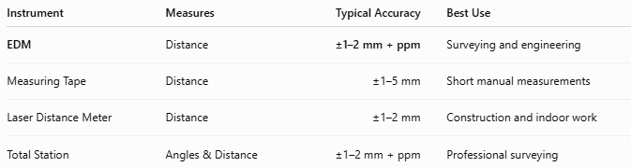
Instrument | Measures | Typical Accuracy | Best Use
EDM | Distance | ±1–2 mm + ppm | Surveying and engineering
Measuring Tape | Distance | ±1–5 mm | Short manual measurements
Laser Distance Meter | Distance | ±1–2 mm | Construction and indoor work
Total Station | Angles & Distance | ±1–2 mm + ppm | Professional surveying

Care and Maintenance
# Source: AI Source: Provided by: [Data Path: Persons Table -> ID Column: 1, Name_En Column: Motasem Essam] -> From: [ChatGPT] on [7/17/2026]
To maintain accuracy:
- Clean lenses regularly.
- Protect the instrument from moisture and dust.
- Store in a padded carrying case.
- Calibrate periodically.
- Keep batteries fully charged.

Common Mistakes
# Source: AI Source: Provided by: [Data Path: Persons Table -> ID Column: 1, Name_En Column: Motasem Essam] -> From: [ChatGPT] on [7/17/2026]
- Measuring without proper leveling.
- Incorrect prism alignment.
- Measuring through obstacles.
- Ignoring atmospheric corrections.
- Using the wrong measurement mode.

Key Points
# Source: AI Source: Provided by: [Data Path: Persons Table -> ID Column: 1, Name_En Column: Motasem Essam] -> From: [ChatGPT] on [7/17/2026]
- EDM stands for Electronic Distance Measurement.
- It measures distance, not angle directly.
- Common types:
  - Infrared EDM
  - Laser EDM
  - Microwave EDM
  - Total Station EDM
- Common units:
  - mm
  - cm
  - m
  - km
- EDM technology is fundamental to modern surveying and engineering.

Conclusion
# Source: AI Source: Provided by: [Data Path: Persons Table -> ID Column: 1, Name_En Column: Motasem Essam] -> From: [ChatGPT] on [7/17/2026]
An Electronic Distance Measurement (EDM) instrument is a high-precision surveying device used to measure distances by transmitting electromagnetic waves. Although its primary function is distance measurement, it is commonly associated with angle-measuring instruments because it is integrated into total stations, enabling simultaneous measurement of angles, distances, and coordinates. EDM technology has become an essential component of modern surveying, civil engineering, construction, mapping, and geodetic applications.

